**Let’s get a taste of Linux:**

Explore the “Web-based” Linux Compute Portal: <http://bellard.org/jslinux/>

* Create a file there by entering this command:

cd ~; echo "I am JohnXXX\n" > test1; whoami >> test1;

* Let’s see the output of the command above, as show below:

more test1

* Is “test1”, the file still there with a “fresh access/session”?
* Does “vi” works?
* Does “vim” works?
* Test your limits on Linux command. Anything missing? Share your experiences with the class.

NOTE: This will be your computing platform for this class, if you don’t have your own PC.

**Let’s Get Started, Install “Cygwin”:**

“Cywin” is a popular Linux emulator for the Window/OS platform. It is lightweight (meaning, NOT taking too much of your PC’s resources). Best of all, copy/paste from your PC/WindowOS to “Cygwin” works. Also, it has the same file system!

1. Please download, and install “Cygwin” from this link:

<https://cygwin.com/install.html>

1. After installation is complete, launch a “Cygwin” session on your PC.
2. Execute the following commands:

pwd; whoami; uname –a;

1. Try the following commands: vi, vim?
2. Try to install the “vim”, if it is NOT available.
3. Try other Linux commands you know, capture, and share your findings with the class. (e.g. “whoami”, “ipconfig”, “more test1”, “uname –a”… )
4. What are the major differences you see, when comparing with the Web-based Linux?

ANS: Cygwin and Linux both are the C library and when Cygwin installed, users have access to many standard UNIX utilities. And programmers may write Win 32 console or GUI applications which make use of standard microsoft Win 32 API or the Cygwin API.

1. Please navigate to your “Desktop” folder, and show me the screenshots.

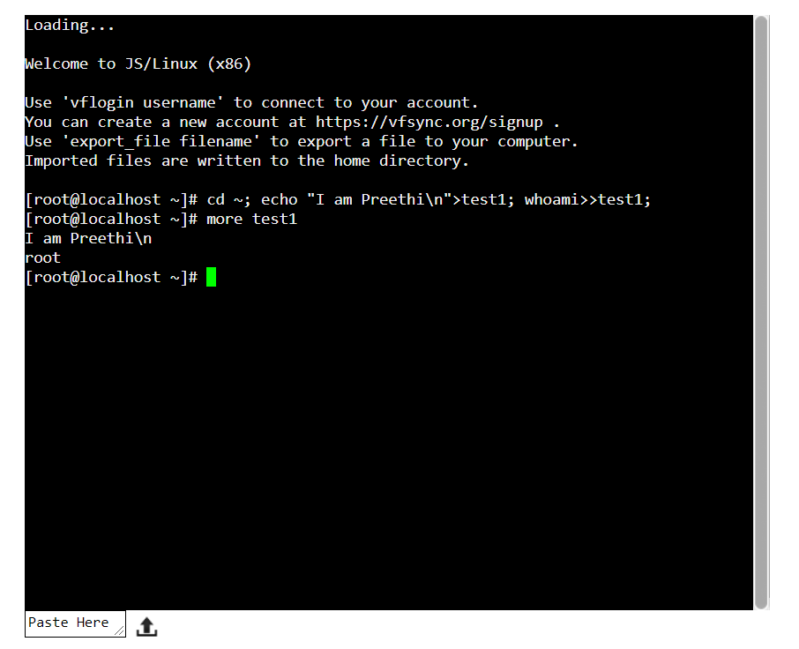

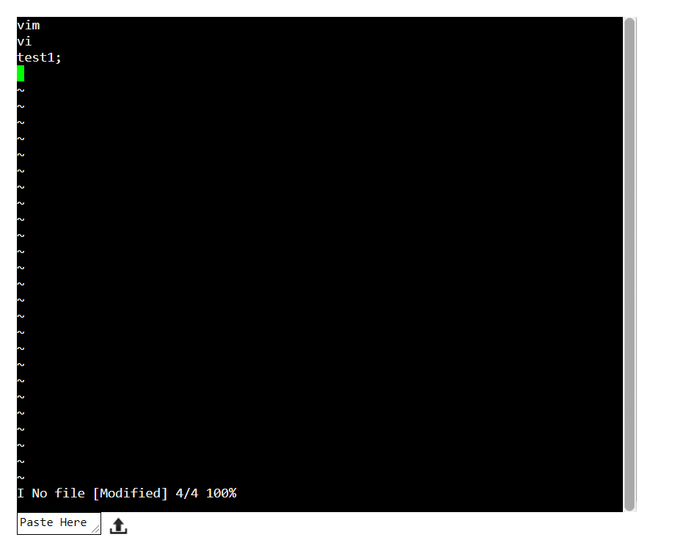

The rest of this module is for you to spend time, and install both “Cygwin”, onto your Laptop/PC and explore!